Data base Design & it's capabilities
Caching Capabilities : Redis
Blob: S3 , CDN
Text Search : Elastic Search , Solar,
Metrix to capture , Monitoring : Time series
we need appended write data
we need a timeseris database
we need range of some date to read
Ex: Open timeseries Database
Big data base for analytics.... need various reports, statistics... warehourse data
ex: Hadoop
Two kinds of DB
1. Structure DB
do we need ACID Yes then RDBMS
ex: mysql, postgresql, sql server

Payment : db,
Atomity , consistency, Integratiry , Durabality
2. unstructure DB
--> like catalog for amazon, ex item can be shirt, refreigirator,milk
lot of datatypes and many wide range queries
then it's Document DB : Mango DB, Couch base.
--> ever increasing data, finite queries
huge data and finite queries
then it's Column DB, cassandra, Hbase

Take example for Amazon Ecommerce
-------------------------------
FOr INventory management : it should be RDBMS, once its' delievred after few days

then we can purge them in cassandra for

then if we want to read range of user recommendations then for queries we can use mongo db
==========

Huge Read intensive --Need to do caching
Huge write intesive--
Maybe this question is better suited for https://softwarerecs.stackexchange.com/
Apart from that, Cassandra performs quite well with many inserts when you have a look on async inserts and batches that hit only one node. We do this every day with >100GB of data.
Keep in mind that you will need a strategy to get rid of old data in any database you choose. One thing cassandra can't handle for you is a "huge" transaction that makes the data visible after the complete inserts done. You have to do this on application side - we use a "marker insert" for this and only do processing in clients when the marker was set already.
Also some guys at Instagram combinded RocksDB and Cassandra to Rocksandra:
https://github.com/Instagram/cassandra/tree/rocks_3.0 https://instagram-engineering.com/open-sourcing-a-10x-reduction-in-apache-cassandra-tail-latency-d64f86b43589

Database Internals:
1. Database internally uses B+ trees
2. serialized and stored in disk.

lets starts simple:
1. rows/records are stored in one file sequentially
2. inserts cannot inserts at the middle of the rows as it may overrides, otherwise we need to create and copy the existing row, locate the position create then insert the records
it takes O(n)
3. update : when we update the records, we should make sure width of the row should not exeed with otherrows otherwise it fringe other row.
4. find one
linear scan

Solution is B+ trees

B+ Tree is balanced binary search tree that can simply be a B Tree, where data is stored in keys, not key-value pairs.
appication/uses : Database systems, file systems, where range queries are common

leaf nodes holds row data..

if leaf nodes hold rows then what holds at higher/parent node...???

non leaf nodes holds routing informations.... range of their childs

all leafs is linearly connected.

update inmemory in flush it to disk

Basically an index on a table works like an index in a book (that's where the name came from):

Let's say you have a book about databases and you want to find some information about, say, storage. Without an index (assuming no other aid, such as a table of contents) you'd have to go through the pages one by one, until you found the topic (that's a full table scan). On the other hand, an index has a list of keywords, so you'd consult the index and see that storage is mentioned on pages 113-120,231 and 354. Then you could flip to those pages directly, without searching (that's a search with an index, somewhat faster).

Of course, how useful the index will be, depends on many things - a few examples, using the simile above:

if you had a book on databases and indexed the word "database", you'd see that it's mentioned on pages 1-59,61-290, and 292 to 400. In such case, the index is not much help and it might be faster to go through the pages one by one (in a database, this is "poor selectivity").
For a 10-page book, it makes no sense to make an index, as you may end up with a 10-page book prefixed by a 5-page index, which is just silly - just scan the 10 pages and be done with it.
The index also needs to be useful - there's generally no point to index e.g. the frequency of the letter "L" per page.

All of these are kinds of indices.

primary: must be unique, is an index, is (likely) the physical index, can be only one per table.

unique: as it says. You can't have more than one row with a tuple of this value. Note that since a unique key can be over more than one column, this doesn't necessarily mean that each individual column in the index is unique, but that each combination of values across these columns is unique.

index: if it's not primary or unique, it doesn't constrain values inserted into the table, but it does allow them to be looked up more efficiently.

fulltext: a more specialized form of indexing that allows full text search. Think of it as (essentially) creating an "index" for each "word" in the specified column

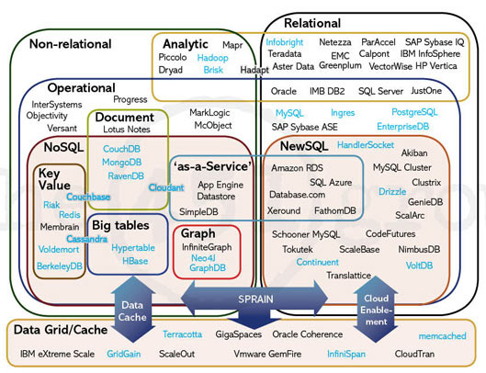

Types of NoSQL database: Types of NoSQL databases and the name of the database system that falls in that category are:
- Graph Databases: Examples – Amazon Neptune, Neo4j
- Key value store: Examples – Memcached, Redis, Coherence
- Column: Examples – Hbase, Big Table, Accumulo
- Document-based: Examples – MongoDB, CouchDB, Cloudant
When should NoSQL be used:
- When a huge amount of data needs to be stored and retrieved.
- The relationship between the data you store is not that important
- The data changes over time and is not structured.
- Support of Constraints and Joins is not required at the database level
- The data is growing continuously and you need to scale the database regularly to handle the data.

Types of NoSQL databases
To support specific needs and use cases, NoSQL databases use a variety of data models for managing and accessing the data. The following section describes some of the common NoSQL database categories:
- Key-value pair
- Document-oriented
- Column-oriented
- Graph-based
- Time series
These types of databases are optimized specifically for applications that need large data volumes, flexible data models, and low latency. To achieve these objectives, NoSQL databases employ various techniques, and it's important to note that not all database options prioritize the same set of factors that are mentioned here:
- Consistency
- Atomicity, Consistency, Isolation, and Durability (ACID) transactions
- Query language and data access richness (simplified Create, Read, Update, and Delete (CRUD)-style operations with known predictable cost)
- Sharding/partitioning of data sets on primary identifier keys
- Shifting the burden of data and schema validation to the application (removing referential integrity enforcement by the database and so on)
Here’s a brief overview of most popular NoSQL data models.
- Key-value — A key-value data store is a type of database that stores data as a collection of key-value pairs. In this type of data store, each data item is identified by a unique key, and the value associated with that key can be anything, such as a string, number, object, or even another data structure.
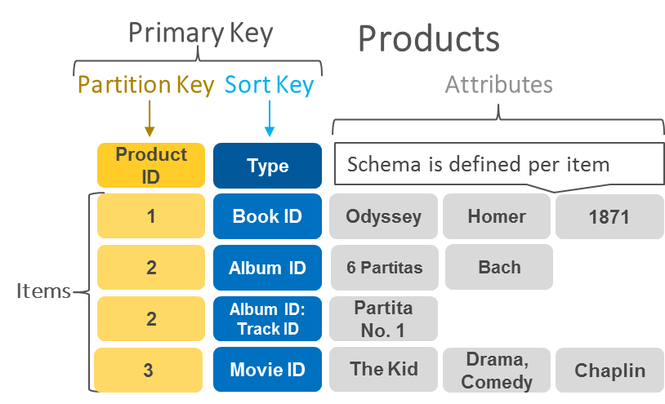
An example of data stored as key-value pairs.
AWS offers Amazon DynamoDB as a key-value managed database service.
- Document — In a document database, the data is stored in documents. Each document is typically a nested structure of keys and values. The values can be atomic data types, or complex elements such as lists, arrays, nested objects, or child collections (for example, a collection in the document database is analogous to a table in a relational database, except there is no single schema enforced upon all documents).
Documents are retrieved by unique keys. It may also be possible to retrieve only parts of a document--for example, the cost of an item--to run queries such as aggregation, querying using examples based on a text string, or even full-text search. Most document databases also allow you to define secondary indexes.
You can transfer the application code object model directly into a document using several different formats. The most commonly used are JavaScript Object Notation (JSON), Binary JavaScript Object Notation (BSON), and Extensible Markup Language (XML).
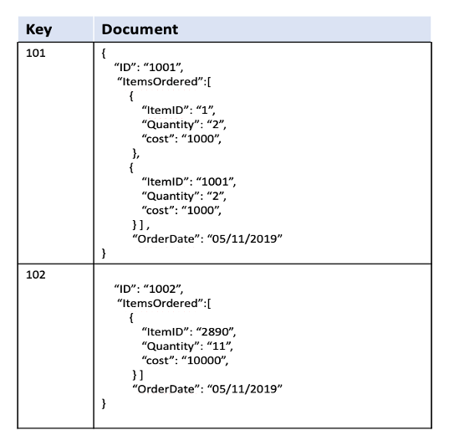
An example of a document data model
AWS offers a specialized document database service called Amazon DocumentDB (with MongoDB compatibility).
- Wide-column — A wide column data store is a type of NoSQL database that stores data in columns rather than rows, making it highly scalable and flexible. In a wide column data store, data is organized into column families, which are groups of columns that share the same attributes. Each row in a wide column data store is identified by a unique row key, and the columns in that row are further divided into column names and values.
Unlike traditional relational databases, which have a fixed number of columns and data types, wide column data stores allow for a variable number of columns and support multiple data types. The most significant benefit of having column-oriented databases is that you can store large amounts of data within a single column. This feature allows you to reduce disk resources and the time it takes to retrieve information from it.
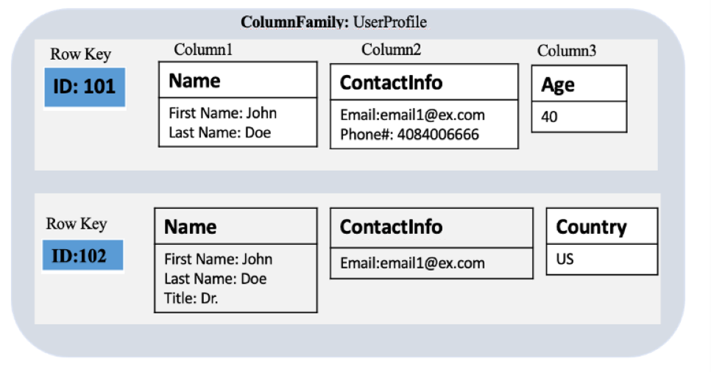
An example of the kind of data you might store in a wide-column data store
AWS offers Amazon Keyspaces (for Apache Cassandra) as a wide-column managed database service.
- Graph — Graph databases are used to store and query highly connected data. Data can be modeled in the form of entities (also referred to as nodes, or vertices) and the relationships between those entities (also referred to as edges). The strength or nature of the relationships also carry significant meaning in graph databases.
Users can then traverse the graph structure by starting at a defined set of nodes or edges and travel across the graph, along defined relationship types or strengths, until they reach some defined condition. Results can be returned in the form of literals, lists, maps, or graph traversal paths. Graph databases provide a set of query languages that contain syntax designed for traversing a graph structure, or matching a certain structural pattern.
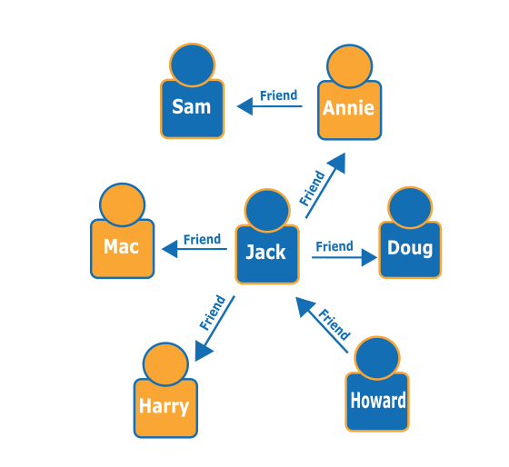
An example of a social network graph. Given the people (nodes) and their relationships (edges), you can find out who the "friends of friends" of a particular person are—for example, the friends of Howard's friends.
AWS offers Amazon Neptune as a managed graph database service.
- Time series — A time series database is designed to store and retrieve data records that are sequenced by time, which are sets of data points that are associated with timestamps and stored in time sequence order. Time series databases make it easy to measure how measurements or events change over time; for example, temperature readings from weather sensors or intraday stock prices.
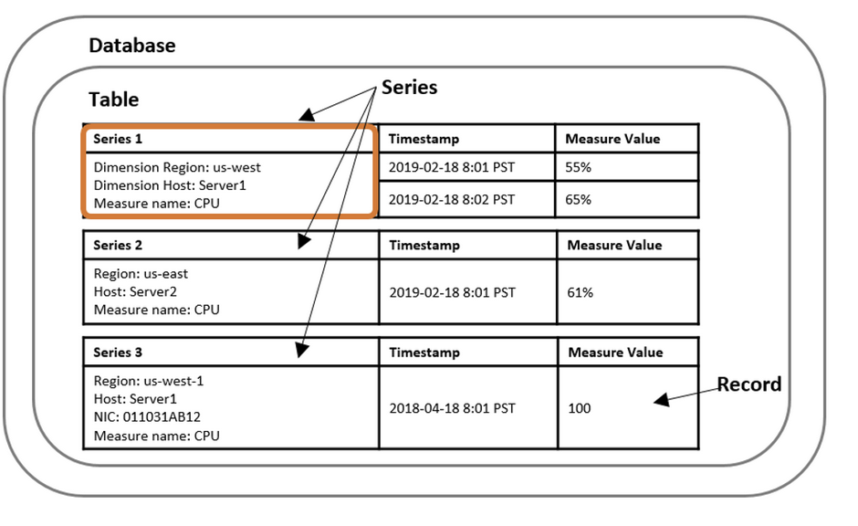
An example of a series data model
AWS offers Amazon Timestream as a managed time series database service.

